Locus and Perpendicular Bisector

Definition
# Source: AI Source: Provided by: [Data Path: Persons Table -> ID Column: 1, Name_En Column: Motasem Essam] -> From: [ChatGPT] on [7/25/2026]
The perpendicular bisector locus is the locus of all points that are equidistant from two fixed points.
Given two distinct fixed points $A$and $B$, the locus of all points $P$satisfying
$$\boxed{PA=PB}$$
is the perpendicular bisector of $\overset{‾}{AB}$.
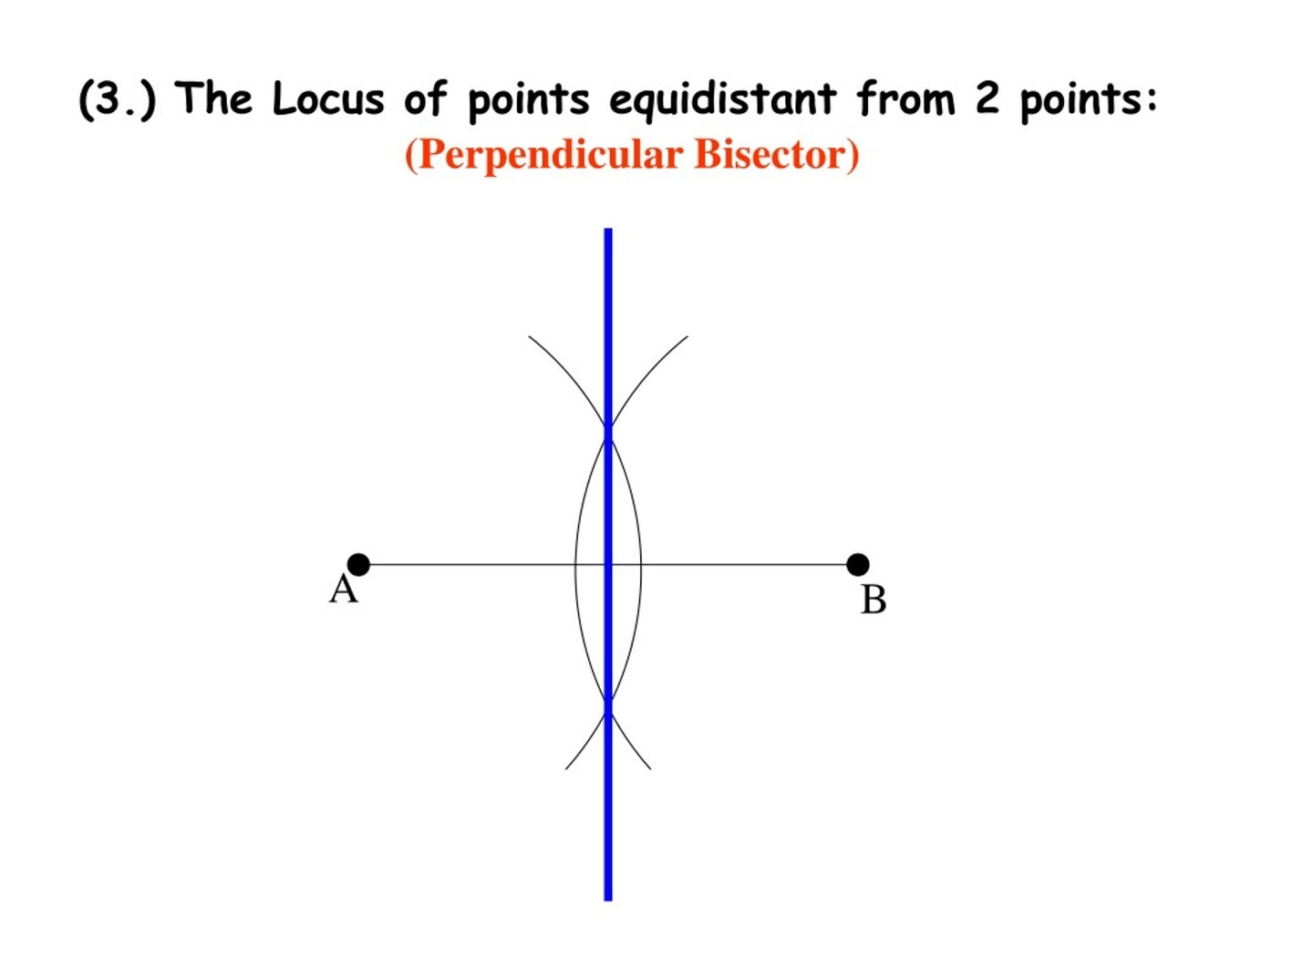
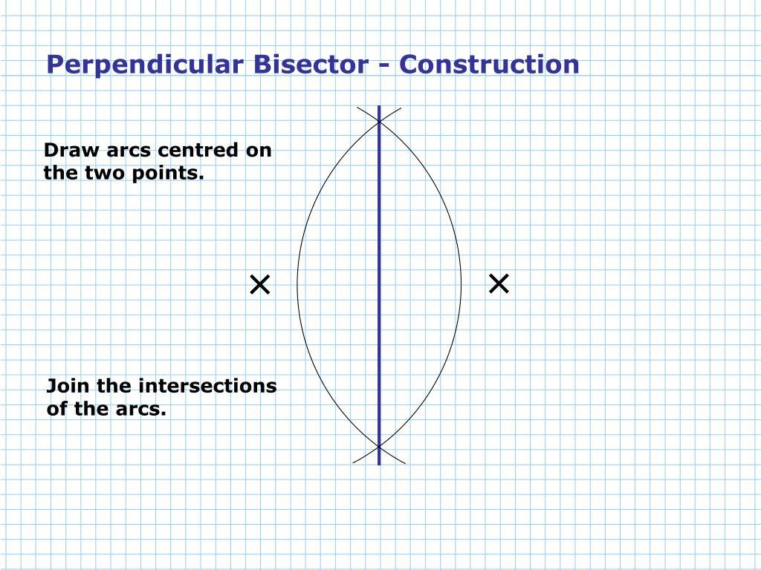
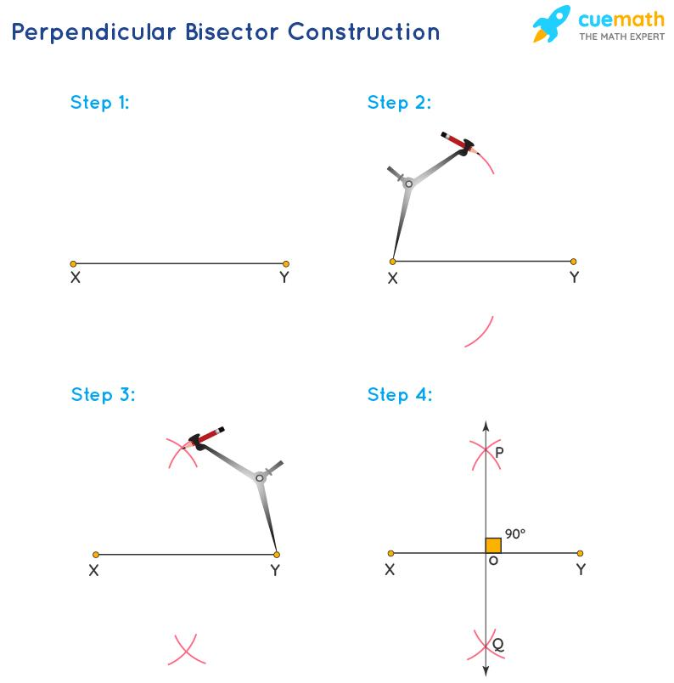
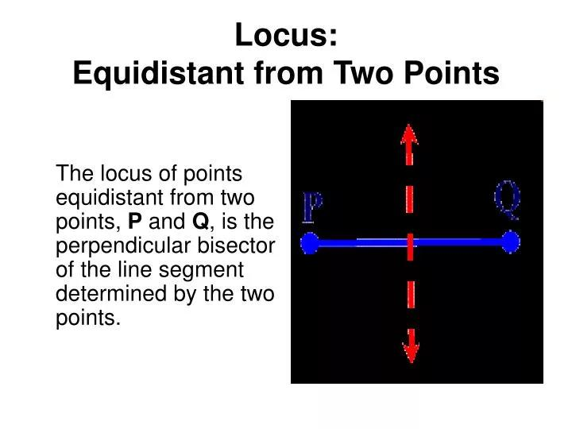
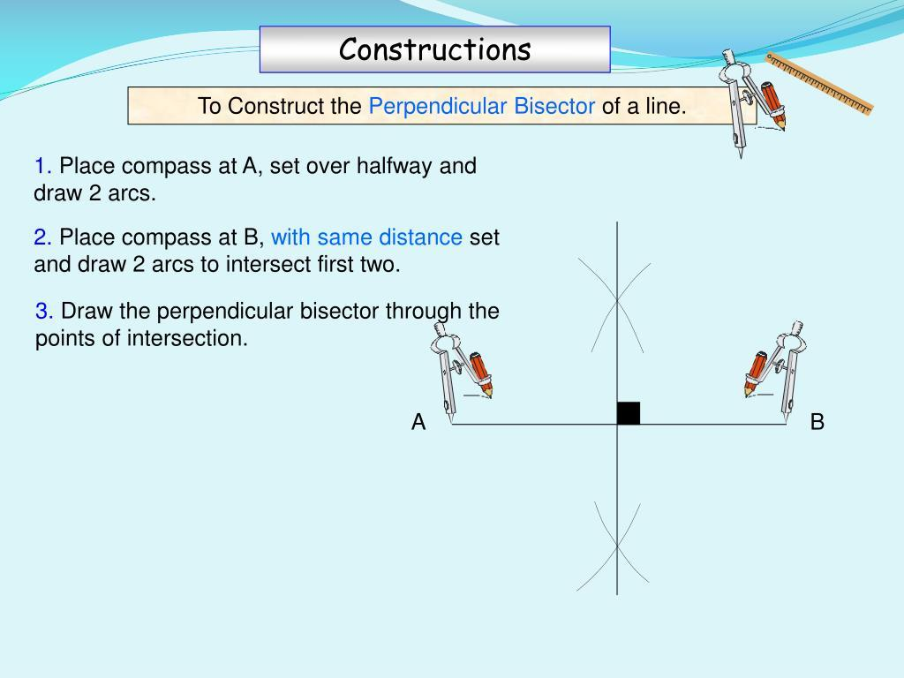

Simple Definition
# Source: AI Source: Provided by: [Data Path: Persons Table -> ID Column: 1, Name_En Column: Motasem Essam] -> From: [ChatGPT] on [7/25/2026]
The perpendicular bisector of a segment is the locus of all points that are equally distant from the two endpoints of the segment.
Therefore:
$$\boxed{PA=PB ⟺ P\text{ lies on the perpendicular bisector of }AB}$$
This is one of the most important equal-distance loci in Euclidean geometry.

Fundamental Concept
# Source: AI Source: Provided by: [Data Path: Persons Table -> ID Column: 1, Name_En Column: Motasem Essam] -> From: [ChatGPT] on [7/25/2026]
Let $A$and $B$be two fixed points.
We want to find every point $P$satisfying
$$PA=PB.$$
There are infinitely many such points.
All of them lie on one straight line that:
- passes through the midpoint of $AB$, and
- is perpendicular to $AB$.
That line is called the perpendicular bisector of $AB$.
$$\boxed{\text{Equidistant from two points}→\text{Perpendicular Bisector}}$$

Perpendicular Bisector as a Locus
# Source: AI Source: Provided by: [Data Path: Persons Table -> ID Column: 1, Name_En Column: Motasem Essam] -> From: [ChatGPT] on [7/25/2026]
Suppose $M$is the midpoint of $\overset{‾}{AB}$.
Then
$$AM=MB$$
and the perpendicular bisector is the line through $M$perpendicular to $AB$.
Every point $P$on this line satisfies
$$\boxed{PA=PB}.$$
Thus:
$$\boxed{\text{Locus of }P\text{ such that }PA=PB=\text{perpendicular bisector of }AB}$$
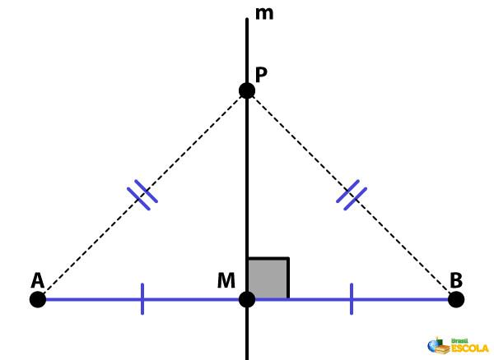
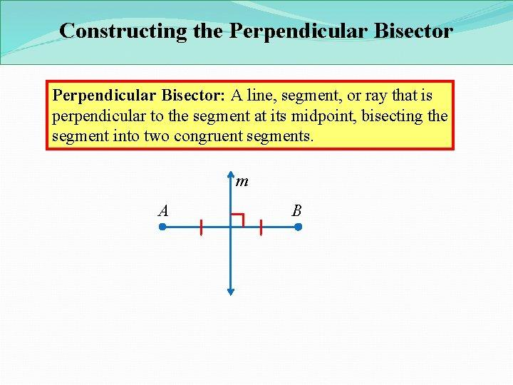
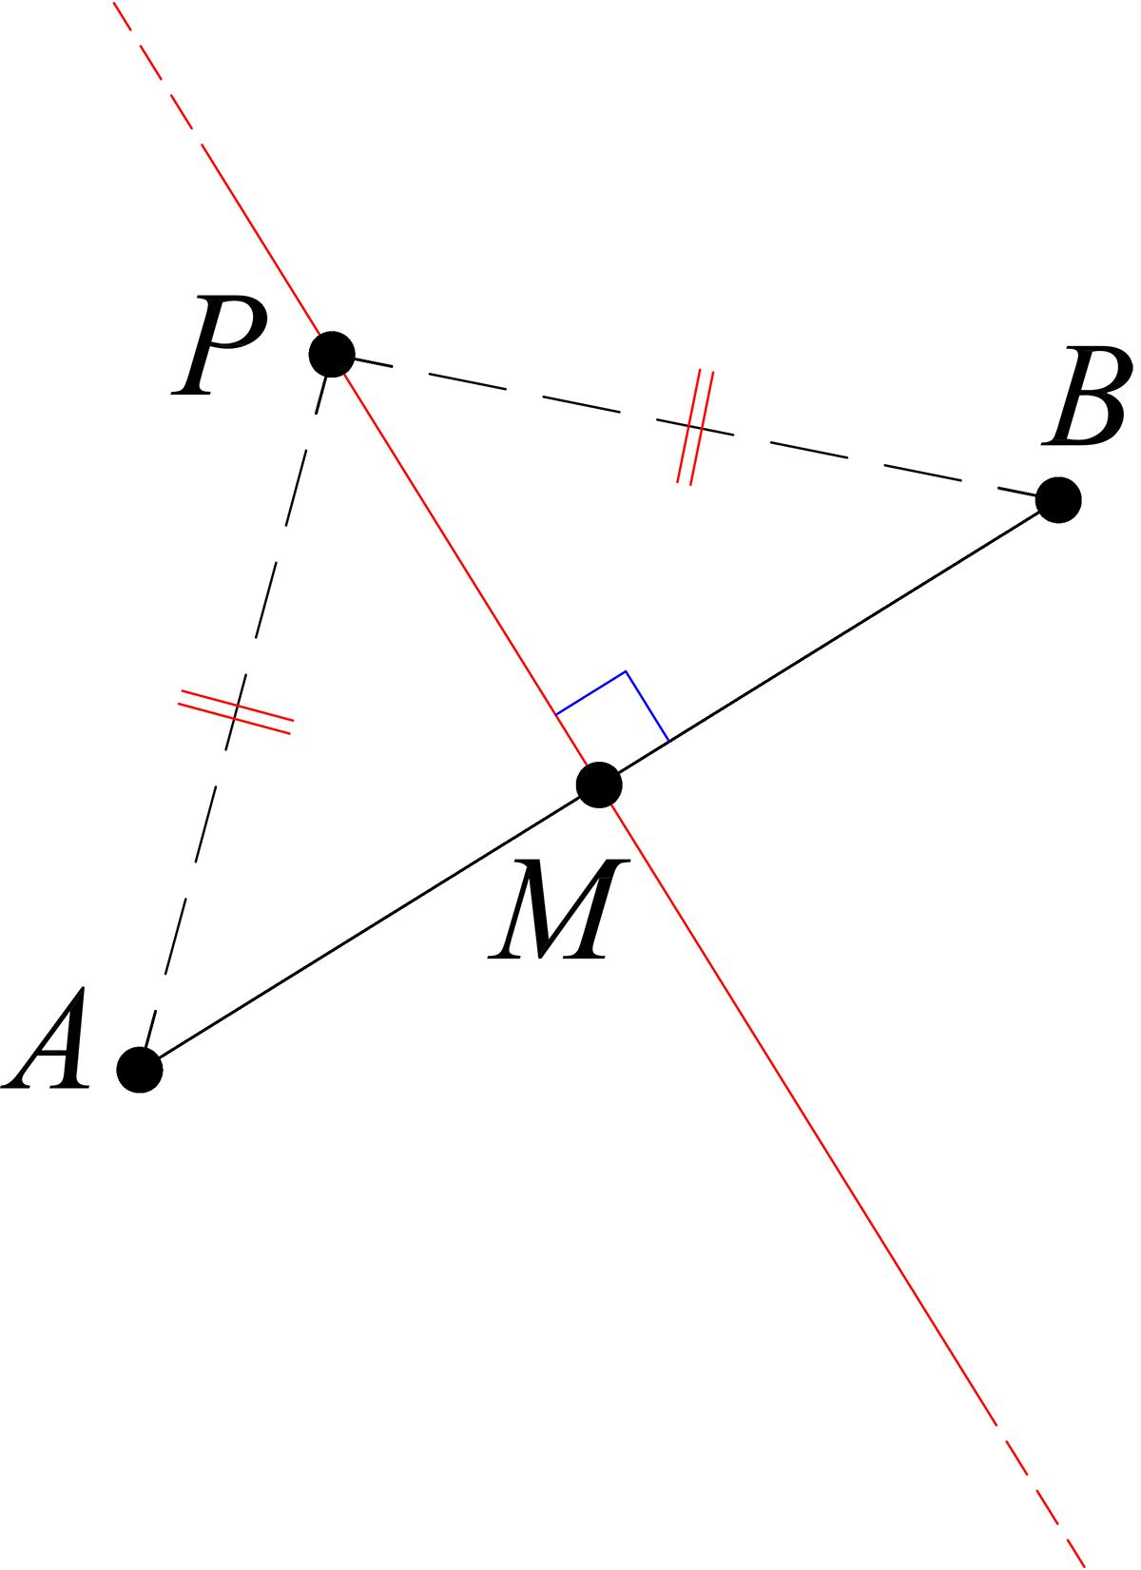
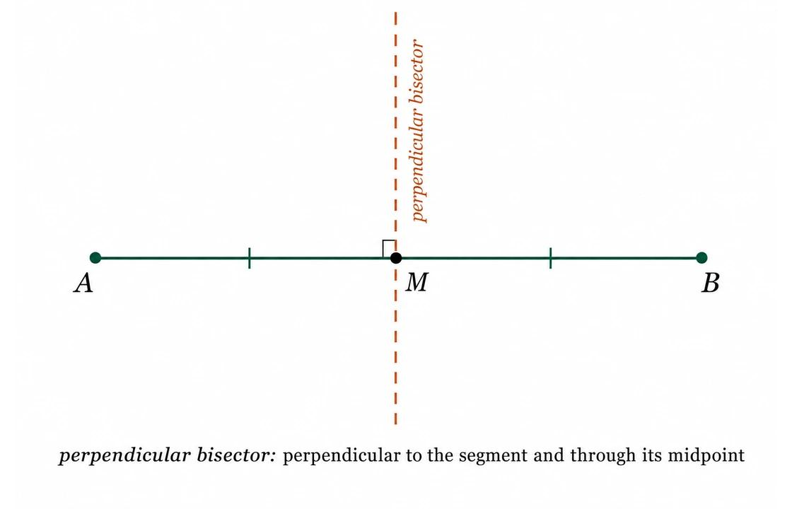

Why Does the Locus Form a Straight Line?
# Source: AI Source: Provided by: [Data Path: Persons Table -> ID Column: 1, Name_En Column: Motasem Essam] -> From: [ChatGPT] on [7/25/2026]
Take a point $P$on the perpendicular bisector.
Since $M$is the midpoint:
$$AM=MB.$$
Since the perpendicular bisector is perpendicular to $AB$:
$$∠AMP=∠BMP={90}^{∘}.$$
Also,
$$PM=PM.$$
Therefore the right triangles
$$△AMP$$
and
$$△BMP$$
are congruent by RHS/HL.
Hence:
$$\boxed{PA=PB}.$$
Therefore every point on the perpendicular bisector satisfies the locus condition.

Converse: Every Equidistant Point Lies on the Bisector
# Source: AI Source: Provided by: [Data Path: Persons Table -> ID Column: 1, Name_En Column: Motasem Essam] -> From: [ChatGPT] on [7/25/2026]
The converse is equally important.
Suppose a point $P$satisfies
$$PA=PB.$$
Let $M$be the midpoint of $AB$.
Then:
$$AM=MB, \\ PA=PB,$$
and
$$PM=PM.$$
Therefore,
$$△PAM≅△PBM$$
by SSS.
Consequently,
$$∠PMA=∠PMB.$$
These two angles form a straight angle, so each must be
$${90}^{∘}.$$
Thus:
$$PM⊥AB.$$
Since $M$is the midpoint and $PM⊥AB$, $P$lies on the perpendicular bisector.
Therefore:
$$\boxed{PA=PB⇒P\text{ lies on the perpendicular bisector of }AB}$$
Together:
$$\boxed{PA=PB ⟺ P\text{ lies on the perpendicular bisector of }AB}$$

Construction of the Perpendicular-Bisector Locus
# Source: AI Source: Provided by: [Data Path: Persons Table -> ID Column: 1, Name_En Column: Motasem Essam] -> From: [ChatGPT] on [7/25/2026]
The perpendicular bisector can be constructed with a compass and straightedge.
Steps
- Draw the fixed segment $\overset{‾}{AB}$.
- Open the compass to a radius greater than half of $AB$.
- With center $A$, draw arcs above and below $AB$.
- With the same compass radius and center $B$, draw arcs intersecting the first pair.
- Connect the two arc-intersection points.
- The resulting line is the perpendicular bisector of $AB$.
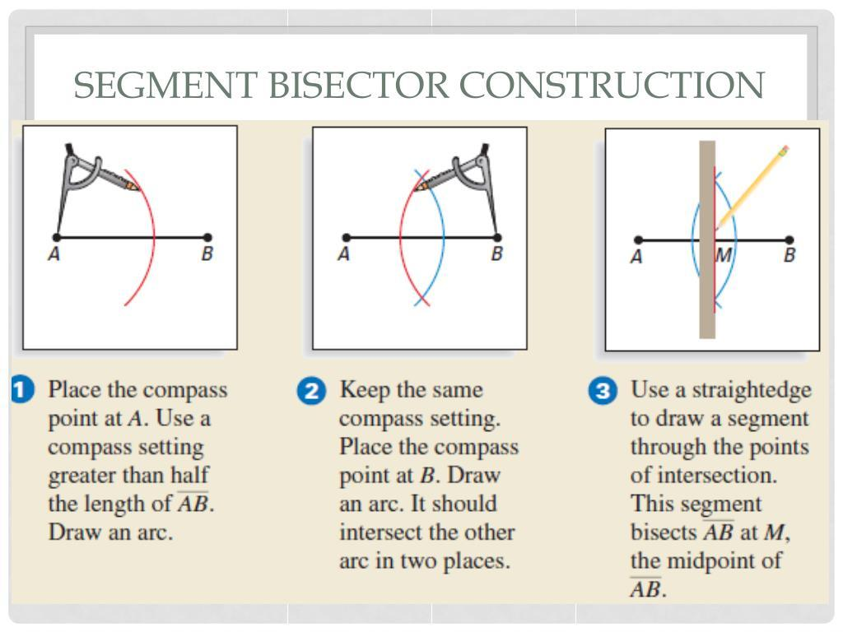
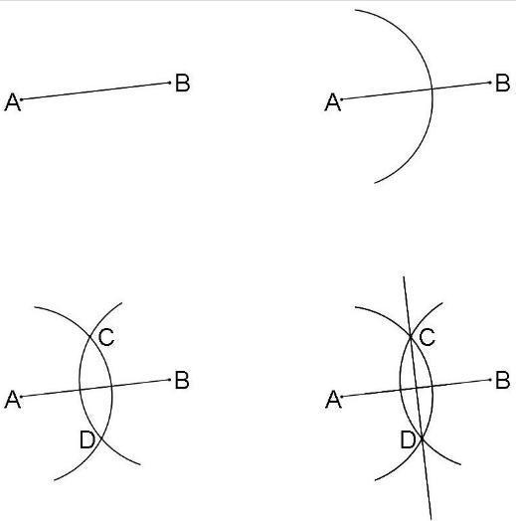
The two arc intersections are themselves points equidistant from $A$and $B$.

Example
# Source: AI Source: Provided by: [Data Path: Persons Table -> ID Column: 1, Name_En Column: Motasem Essam] -> From: [ChatGPT] on [7/25/2026]
Suppose
$$A=\left(0 , 0\right), B=\left(6 , 0\right).$$
The midpoint is
$$M=\left(\frac{0+6}{2} , 0\right)$$
so
$$M=\left(3 , 0\right).$$
Because $AB$is horizontal, its perpendicular bisector is vertical:
$$\boxed{x=3}.$$
Therefore, the locus is
$$\boxed{x=3}.$$
Every point
$$P=\left(3 , y\right)$$
satisfies
$$PA=PB.$$
For example, take
$$P=\left(3 , 4\right).$$
Then
$$PA=\sqrt{{\left(3-0\right)}^{2}+{\left(4-0\right)}^{2}}=\sqrt{25}=5,$$
and
$$PB=\sqrt{{\left(3-6\right)}^{2}+{\left(4-0\right)}^{2}}=\sqrt{25}=5.$$
Therefore:
$$\boxed{PA=PB=5}.$$

Coordinate Equation of the Locus
# Source: AI Source: Provided by: [Data Path: Persons Table -> ID Column: 1, Name_En Column: Motasem Essam] -> From: [ChatGPT] on [7/25/2026]
Let
$$A=\left(x_{1} , y_{1}\right)$$
and
$$B=\left(x_{2} , y_{2}\right).$$
For a general point
$$P=\left(x , y\right),$$
the condition
$$PA=PB$$
gives
$$\sqrt{{\left(x-x_{1}\right)}^{2}+{\left(y-y_{1}\right)}^{2}}=\sqrt{{\left(x-x_{2}\right)}^{2}+{\left(y-y_{2}\right)}^{2}}.$$
Squaring:
$${\left(x-x_{1}\right)}^{2}+{\left(y-y_{1}\right)}^{2}={\left(x-x_{2}\right)}^{2}+{\left(y-y_{2}\right)}^{2}.$$
After simplification, the quadratic terms cancel, leaving a linear equation.
Thus, the locus is a straight line.

Example with Non-Horizontal Points
# Source: AI Source: Provided by: [Data Path: Persons Table -> ID Column: 1, Name_En Column: Motasem Essam] -> From: [ChatGPT] on [7/25/2026]
Let
$$A=\left(1 , 2\right), B=\left(7 , 2\right).$$
The midpoint is
$$M=\left(4 , 2\right).$$
Since $AB$is horizontal, its perpendicular bisector is
$$\boxed{x=4}.$$
For any point
$$P=\left(4 , y\right),$$
we have
$$PA=PB.$$

Example with a Slanted Segment
# Source: AI Source: Provided by: [Data Path: Persons Table -> ID Column: 1, Name_En Column: Motasem Essam] -> From: [ChatGPT] on [7/25/2026]
Let
$$A=\left(0 , 0\right), B=\left(4 , 6\right).$$
The midpoint is
$$M=\left(2 , 3\right).$$
The slope of $AB$is
$$m_{AB}=\frac{6-0}{4-0}=\frac{3}{2}.$$
Therefore, the perpendicular slope is
$$m=-\frac{2}{3}.$$
The perpendicular bisector passes through $\left(2 , 3\right)$, so:
$$y-3=-\frac{2}{3}\left(x-2\right).$$
Multiplying by $3$:
$$3y-9=-2x+4.$$
Therefore:
$$\boxed{2x+3y=13}.$$
This is the locus of all points $P$satisfying
$$PA=PB.$$

Relationship with Distance
# Source: AI Source: Provided by: [Data Path: Persons Table -> ID Column: 1, Name_En Column: Motasem Essam] -> From: [ChatGPT] on [7/25/2026]
The perpendicular bisector divides the plane according to which fixed point is closer.
For points on the perpendicular bisector:
$$\boxed{PA=PB}.$$
On one side:
$$\boxed{PA<PB}.$$
On the other side:
$$\boxed{PB<PA}.$$
Thus:
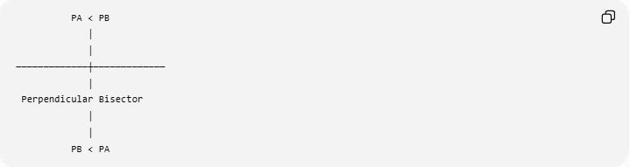
PA < PB
│
│
─────────────┼─────────────
│
Perpendicular Bisector
│
│
PB < PA
The perpendicular bisector itself is the boundary between the two regions.

Voronoi Interpretation
# Source: AI Source: Provided by: [Data Path: Persons Table -> ID Column: 1, Name_En Column: Motasem Essam] -> From: [ChatGPT] on [7/25/2026]
The perpendicular bisector is also the boundary separating the regions that are closer to $A$and closer to $B$.
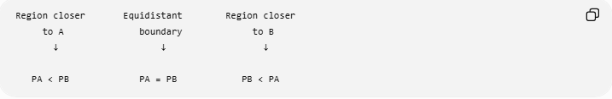
Region closer Equidistant Region closer
to A boundary to B
↓ ↓ ↓

PA < PB PA = PB PB < PA
This idea is fundamental in Voronoi diagrams.
For two sites $A$and $B$, the perpendicular bisector is their Voronoi boundary.

Perpendicular Bisector and Circumcenter
# Source: AI Source: Provided by: [Data Path: Persons Table -> ID Column: 1, Name_En Column: Motasem Essam] -> From: [ChatGPT] on [7/25/2026]
The perpendicular-bisector locus is fundamental to the construction of a triangle's circumcircle.
For a triangle
$$△ABC,$$
the circumcenter $O$satisfies:
$$OA=OB$$
and
$$OA=OC.$$
Therefore, $O$lies on:
- the perpendicular bisector of $AB$,
- the perpendicular bisector of $AC$.
Their intersection gives $O$.
Then:
$$\boxed{OA=OB=OC}.$$
The circle centered at $O$through $A,B,C$is the circumcircle.
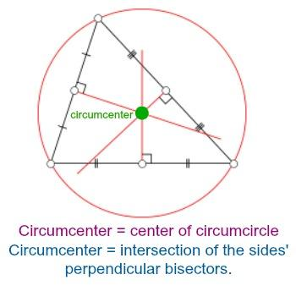
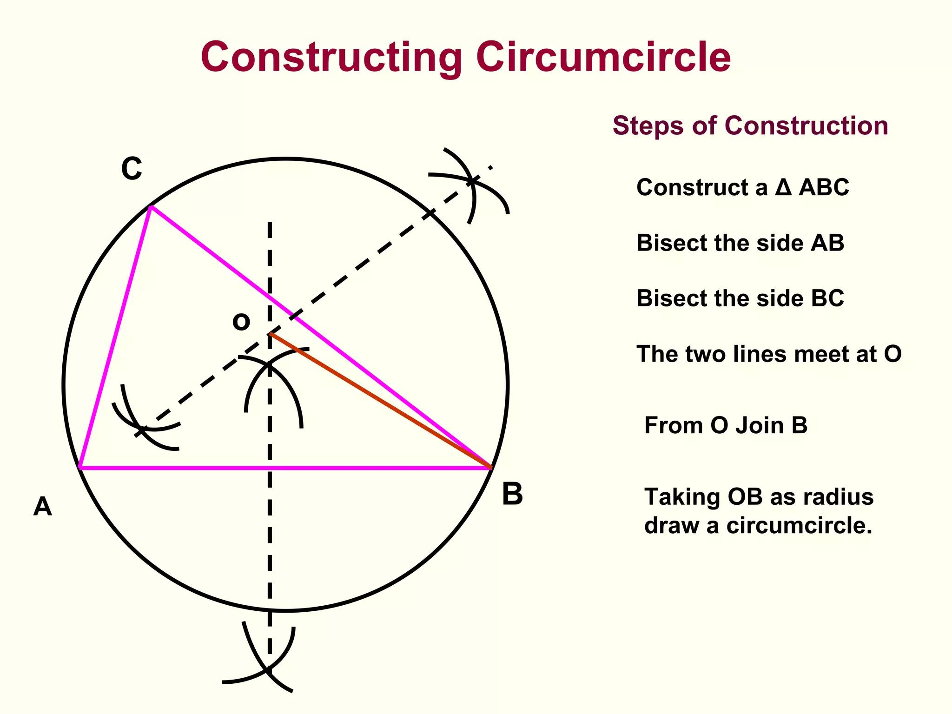
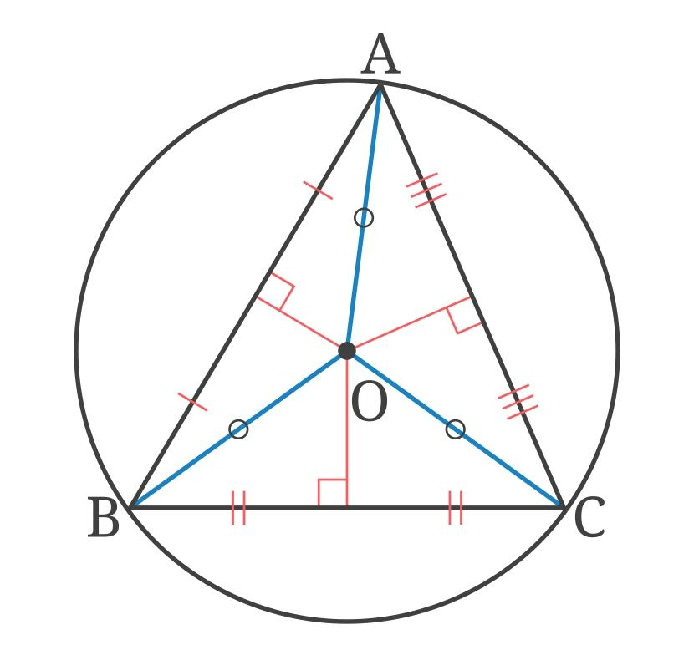
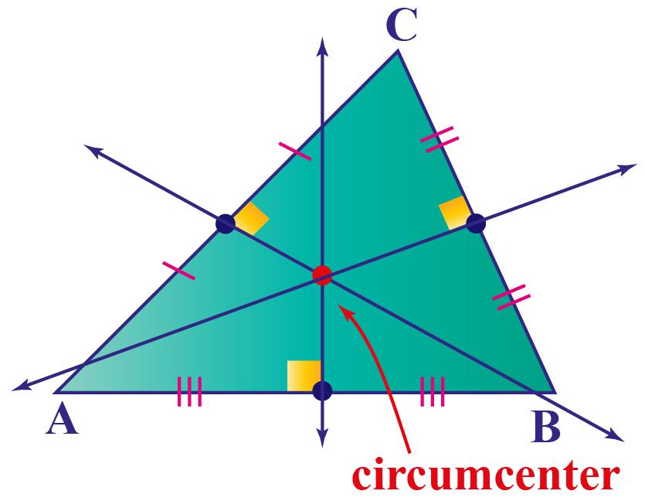
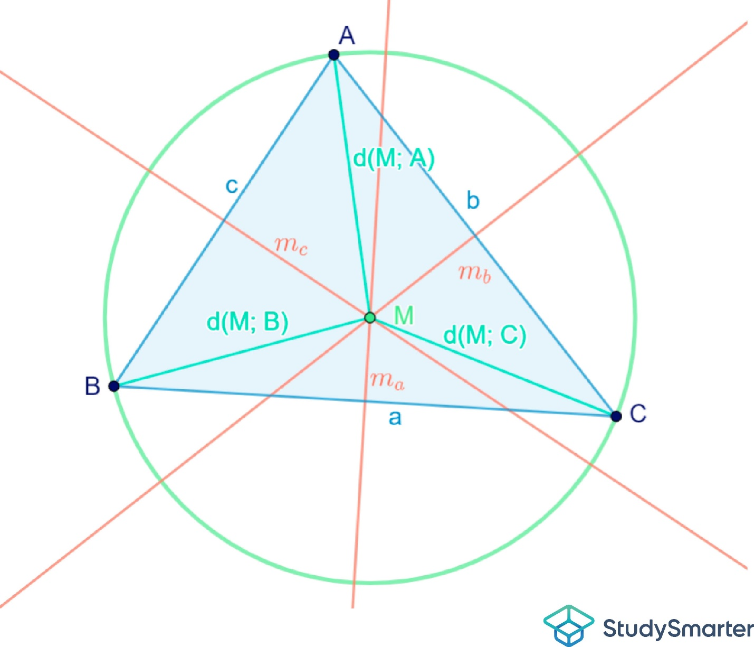
Therefore:
$$\boxed{\text{Perpendicular-Bisector Loci}→\text{Circumcenter}→\text{Circumcircle}}$$

Perpendicular Bisector and Equal-Distance Loci
# Source: AI Source: Provided by: [Data Path: Persons Table -> ID Column: 1, Name_En Column: Motasem Essam] -> From: [ChatGPT] on [7/25/2026]
This is one of the standard equal-distance loci.
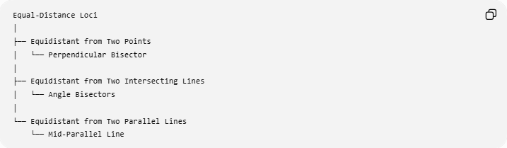
Equal-Distance Loci
│
├── Equidistant from Two Points
│ └── Perpendicular Bisector
│
├── Equidistant from Two Intersecting Lines
│ └── Angle Bisectors
│
└── Equidistant from Two Parallel Lines
└── Mid-Parallel Line
So:
$$\boxed{PA=PB→\text{Perpendicular Bisector}}$$

Perpendicular Bisector vs Fixed-Distance Locus
# Source: AI Source: Provided by: [Data Path: Persons Table -> ID Column: 1, Name_En Column: Motasem Essam] -> From: [ChatGPT] on [7/25/2026]
These two loci are related but different.
Fixed distance from a point
$$OP=r$$
produces a circle.
Equal distance from two points
$$PA=PB$$
produces a perpendicular bisector.
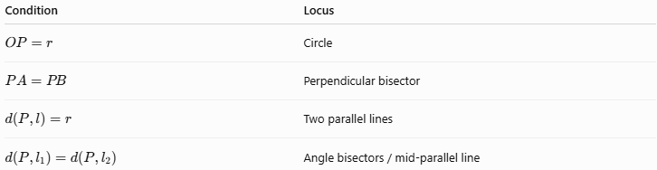
Condition | Locus
$$OP=r$$ | Circle
$$PA=PB$$ | Perpendicular bisector
$$d\left(P , l\right)=r$$ | Two parallel lines
$$d\left(P , l_{1}\right)=d\left(P , l_{2}\right)$$ | Angle bisectors / mid-parallel line
The important difference is:
$$\boxed{\text{Fixed Distance}→\text{Circle}}$$
while
$$\boxed{\text{Equal Distances}→\text{Bisector}}$$

Perpendicular Bisector and a Fixed Segment
# Source: AI Source: Provided by: [Data Path: Persons Table -> ID Column: 1, Name_En Column: Motasem Essam] -> From: [ChatGPT] on [7/25/2026]
The fixed segment $\overset{‾}{AB}$determines the locus.
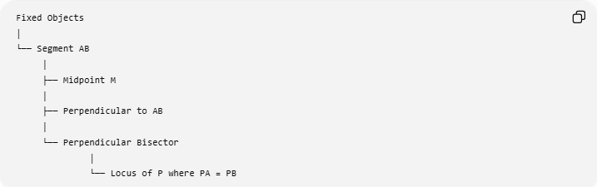
Fixed Objects
│
└── Segment AB
│
├── Midpoint M
│
├── Perpendicular to AB
│
└── Perpendicular Bisector
│
└── Locus of P where PA = PB
The segment itself is not the locus.
Rather, the perpendicular bisector of the segment is the locus.

Important Special Cases
# Source: AI Source: Provided by: [Data Path: Persons Table -> ID Column: 1, Name_En Column: Motasem Essam] -> From: [ChatGPT] on [7/25/2026]
If $A=B$
There are not two distinct fixed points, so the usual perpendicular-bisector locus is not defined in the ordinary sense.
The condition
$$PA=PB$$
becomes automatically true for every $P$.
Thus, the distinct-point condition is important:
$$\boxed{A≠B}.$$
If the problem restricts $P$
The complete locus is the entire perpendicular bisector, but an additional restriction can reduce it.
For example:
$$PA=PB, P∈\text{a given region}$$
means that only the portion of the perpendicular bisector inside that region is included.

Applications
# Source: AI Source: Provided by: [Data Path: Persons Table -> ID Column: 1, Name_En Column: Motasem Essam] -> From: [ChatGPT] on [7/25/2026]
The perpendicular-bisector locus appears in many geometric problems.
1. Finding a point equidistant from two locations
If $A$and $B$are two locations, any point on their perpendicular bisector is equally distant from both.
2. Constructing a circumcenter
The intersection of perpendicular bisectors gives the circumcenter.
3. Constructing a circumcircle
After finding the circumcenter, use the common radius.
4. Nearest-point regions
It separates points closer to $A$from points closer to $B$.
5. Voronoi diagrams
It forms boundaries between regions associated with different sites.
6. Geometric construction
It provides a standard straightedge-and-compass construction for a segment's midpoint and perpendicular line.

Classification
# Source: AI Source: Provided by: [Data Path: Persons Table -> ID Column: 1, Name_En Column: Motasem Essam] -> From: [ChatGPT] on [7/25/2026]
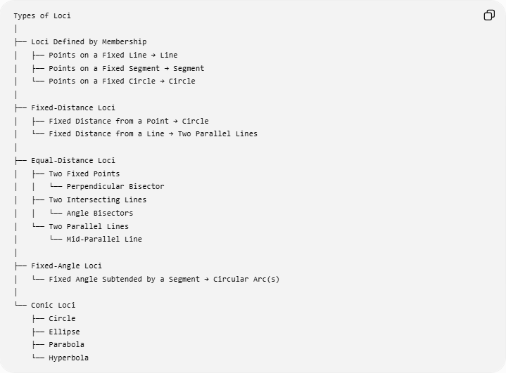
Types of Loci
│
├── Loci Defined by Membership
│ ├── Points on a Fixed Line → Line
│ ├── Points on a Fixed Segment → Segment
│ └── Points on a Fixed Circle → Circle
│
├── Fixed-Distance Loci
│ ├── Fixed Distance from a Point → Circle
│ └── Fixed Distance from a Line → Two Parallel Lines
│
├── Equal-Distance Loci
│ ├── Two Fixed Points
│ │ └── Perpendicular Bisector
│ ├── Two Intersecting Lines
│ │ └── Angle Bisectors
│ └── Two Parallel Lines
│ └── Mid-Parallel Line
│
├── Fixed-Angle Loci
│ └── Fixed Angle Subtended by a Segment → Circular Arc(s)
│
└── Conic Loci
├── Circle
├── Ellipse
├── Parabola
└── Hyperbola

Key Formulas
# Source: AI Source: Provided by: [Data Path: Persons Table -> ID Column: 1, Name_En Column: Motasem Essam] -> From: [ChatGPT] on [7/25/2026]
Locus condition
$$\boxed{PA=PB}$$
Midpoint
$$\boxed{M=\left(\frac{x_{1}+x_{2}}{2} , \frac{y_{1}+y_{2}}{2}\right)}$$
Distance equality
$$\boxed{\sqrt{{\left(x-x_{1}\right)}^{2}+{\left(y-y_{1}\right)}^{2}}=\sqrt{{\left(x-x_{2}\right)}^{2}+{\left(y-y_{2}\right)}^{2}}}$$
Perpendicular relationship
$$\boxed{PM⊥AB}$$
Complete equivalence
$$\boxed{PA=PB ⟺ P\text{ lies on the perpendicular bisector of }AB}$$

Classification Summary
# Source: AI Source: Provided by: [Data Path: Persons Table -> ID Column: 1, Name_En Column: Motasem Essam] -> From: [ChatGPT] on [7/25/2026]
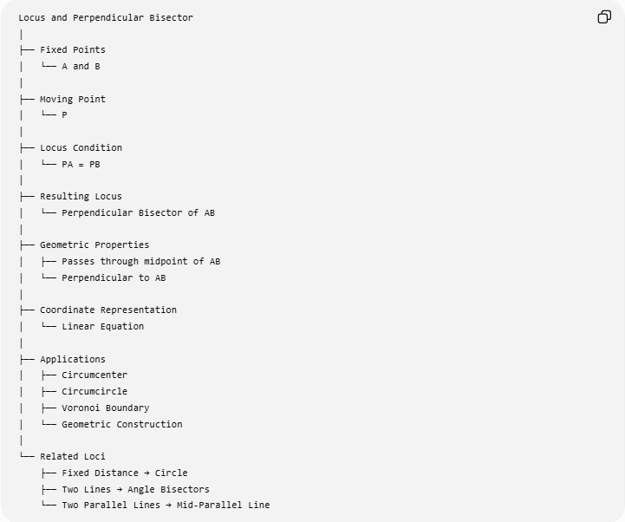
Locus and Perpendicular Bisector
│
├── Fixed Points
│ └── A and B
│
├── Moving Point
│ └── P
│
├── Locus Condition
│ └── PA = PB
│
├── Resulting Locus
│ └── Perpendicular Bisector of AB
│
├── Geometric Properties
│ ├── Passes through midpoint of AB
│ └── Perpendicular to AB
│
├── Coordinate Representation
│ └── Linear Equation
│
├── Applications
│ ├── Circumcenter
│ ├── Circumcircle
│ ├── Voronoi Boundary
│ └── Geometric Construction
│
└── Related Loci
├── Fixed Distance → Circle
├── Two Lines → Angle Bisectors
└── Two Parallel Lines → Mid-Parallel Line

Key Points
# Source: AI Source: Provided by: [Data Path: Persons Table -> ID Column: 1, Name_En Column: Motasem Essam] -> From: [ChatGPT] on [7/25/2026]
- The perpendicular bisector is an equal-distance locus.
- For fixed points $A$and $B$:
$$\boxed{PA=PB}$$
defines the locus.
- The locus is a straight line.
- It passes through the midpoint of $AB$.
- It is perpendicular to $AB$.
- Every point on the perpendicular bisector is equidistant from $A$and $B$.
- Conversely, every point equidistant from $A$and $B$lies on the perpendicular bisector.
- Two perpendicular bisectors of a triangle meet at the circumcenter.
- The perpendicular bisector separates the plane into regions closer to $A$and closer to $B$.

Conclusion
# Source: AI Source: Provided by: [Data Path: Persons Table -> ID Column: 1, Name_En Column: Motasem Essam] -> From: [ChatGPT] on [7/25/2026]
The Perpendicular Bisector is one of the fundamental loci in Euclidean geometry. Given two distinct fixed points $A$and $B$, the complete set of points $P$satisfying
$$\boxed{PA=PB}$$
is exactly the perpendicular bisector of $\overset{‾}{AB}$.
Its central relationship is:
$$\boxed{\text{Equidistance from Two Fixed Points }⟺\text{ Perpendicular Bisector}}$$
This makes the perpendicular bisector a fundamental connection between loci, distance geometry, geometric constructions, circumcenters, circumcircles, and Voronoi geometry.

